Install Ubuntu Server 24.04
- Download Raspberry Pi Imager
- Select Raspberry Pi 5
- Select Other General Purpose OS
- Select Ubuntu
- Select Ubuntu Server 24.04.4 LTS
- Set username and password to: robotics
- Set WiFi to a personal hotspot
- Enable SSH using password authentication
- Write to microSD card

Setting up Network Manager (I only know how on Windows)
This step is optional, using netplan to connect to Wi-Fi is not as elegant as Network Manager, but it works.
- Connect Pi to computer using ethernet and see happy blinking ethernet lights
- Go to View Network Connections
  - 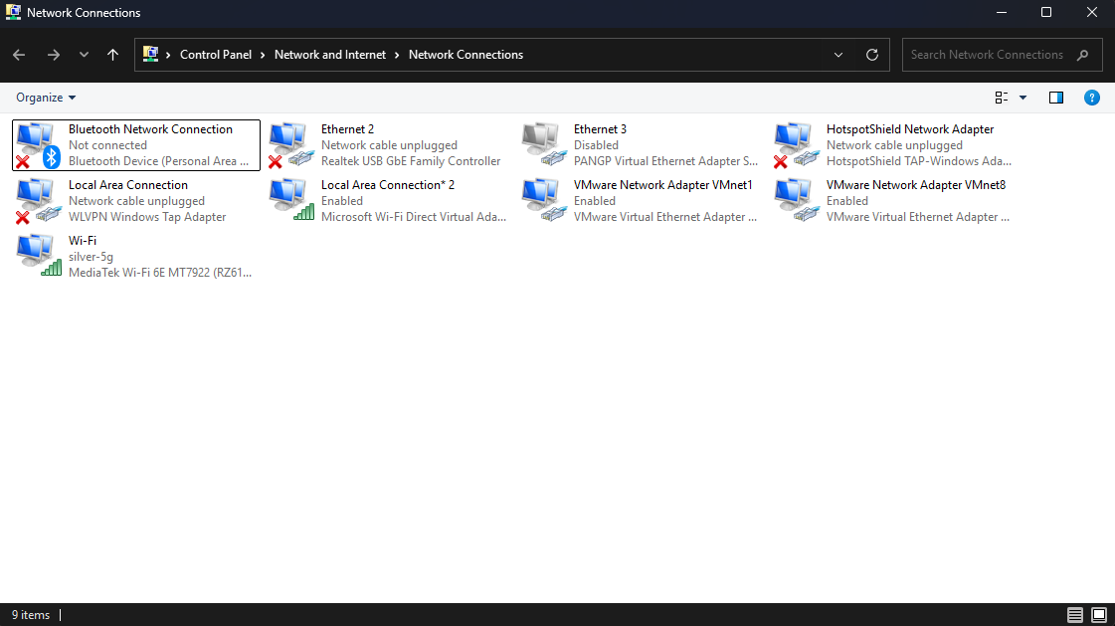
- Open the properties for your computer’s internet connection
  - 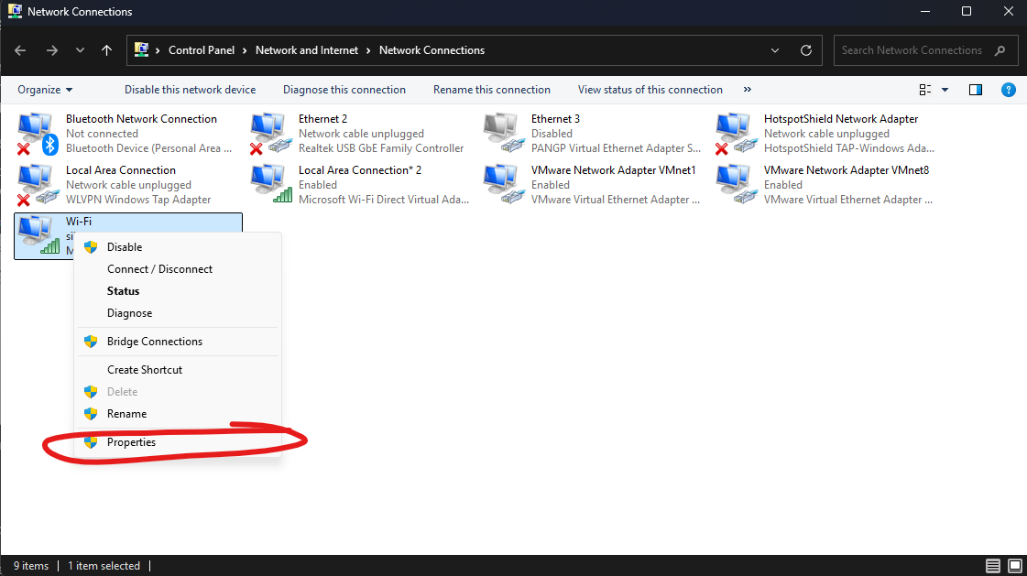
- Share internet connection with Pi
  - 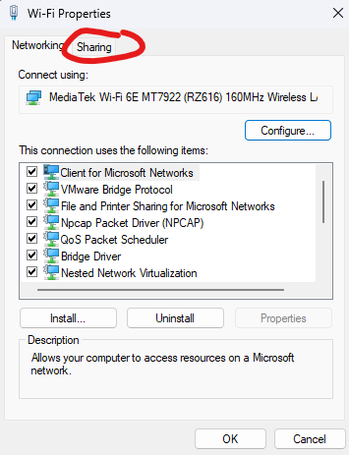
  - 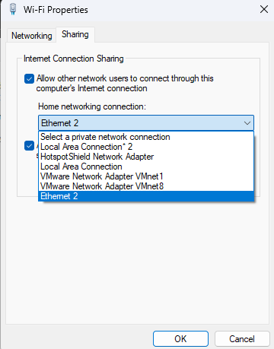
  - In my case, the Pi’s ethernet was connected to Ethernet 2
  - 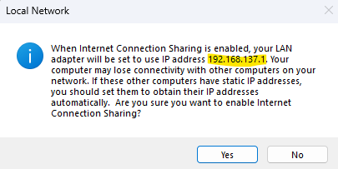
  - Note the IP address
- Find the Pi’s IP address
  - Open terminal and run: arp -a
  - Look for the interface with the IP address from earlier
    - 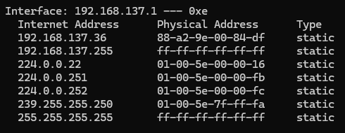
  - Try pinging the devices that start with 192.168.137.XXX
    - ping 192.168.137.36
    - 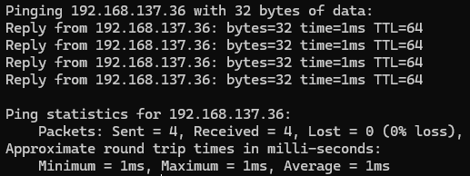
  - Identify the IP addresses that sends a reply
    - In my case it was 192.168.137.36
- Connect to Pi through ssh
  - ssh robotics@192.168.137.36
  - Password should be: robotics
- Hopefully we’re in!
- Install NetworkManager
  - sudo apt update
  - sudo apt upgrade
  - sudo apt install network-manager
- Switch network renderer from netplan (default) to NetworkManager
  - cd /etc/netplan
  - sudo nano 50-cloud-init.yaml or any file that’s there
  - Change renderer: NetworkManager
    - 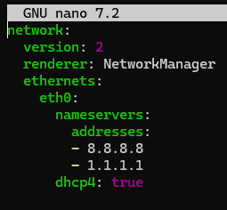
  - Save and exit
  - sudo netplan apply
  - sudo reboot now
  - Hopefully you can use sudo nmtui to change network settings!
    - If not, hopefully the ethernet still works so you can connect to the Pi.
- Set Static IP addresses
  - Set a static IP address using nmtui to: 192.168.0.42
  - Set static IP address on your computer’s ethernet connection
    - IP address: 192.168.0.xxx
      - Xxx can probably be any number between 20 – 255
      - Don’t set it to 192.168.0.42 because that’s the Pi’s address
    - Subnet mask: 255.255.255.0
  - Now, ssh robotics@192.168.0.42, should work over ethernet!

Set up serial port
- cd /boot/firmware
- Edit config.txt
  - Add dtoverlay=uart0,ctsrts underneath enable_uart=1
  - Save file
- Check cmdline.txt
  - Check if it contains console=serial0,115200 and console=tty1
- Reboot pi
  - sudo reboot now
- Now /dev/ttyAMA0 should hopefully point to GPIO pins 14 and 15
